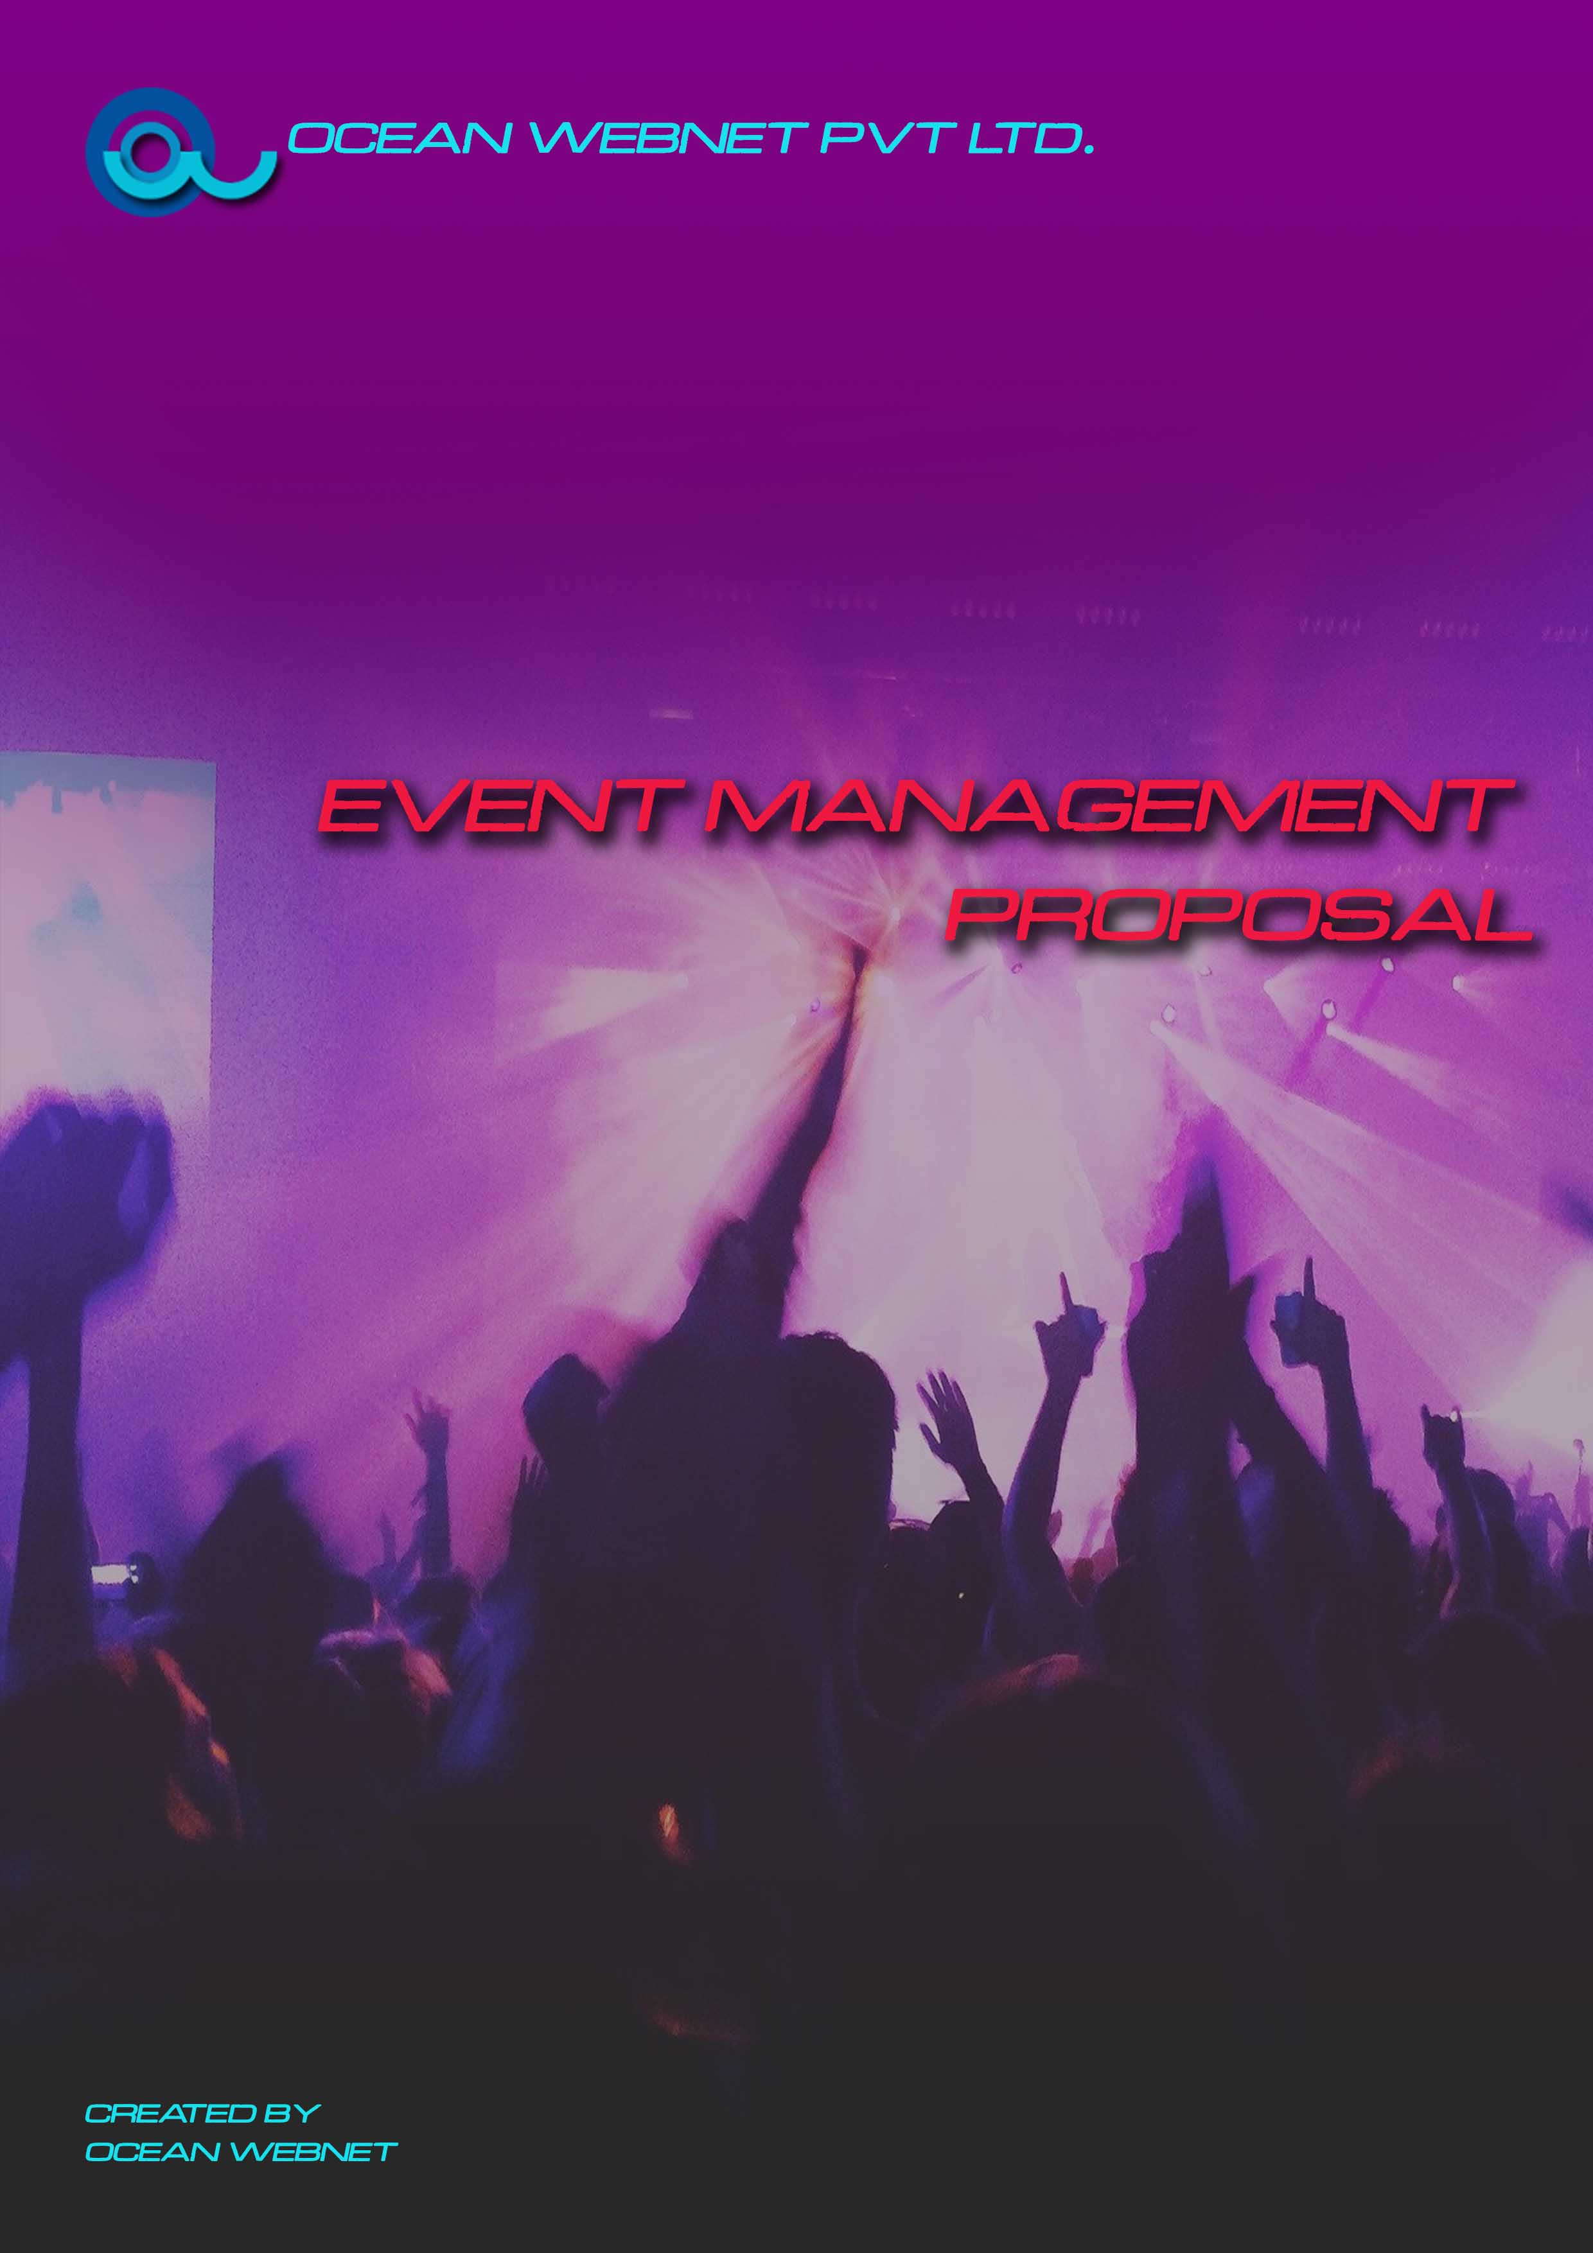
ABOUT US

Ocean Webnet Pvt. Ltd. is a service event management company based in Kolkata. Our team of professionals specializes in taking your event from concept to production.

When the world’s top brands and entertainers need a team of experts to create a compelling audiovisual experience in Kolkata, Ocean Webnet is who they turn to!

What we do?

Design
Our creative team will work with you to flesh out your concept through whiteboard and computer design sessions.

Entertainment
Our network of musical acts, entertainers, and DJs are known for keeping audiences engaged and excited.

Audiovisual
Our award winning audio and video engineers will provide the creativity, equipment, and expertise to put on a world-class show.

Decor & Effects
Our team will help you choose the best decor and special effects to fully complete your theme and create a memorable experience.

Catering
We’ve partnered with renowned caterers in the area to make sure that the food and drink at your event is just as memorable as the rest of the experience.

Grounds, Security, & Transportation
Our shuttles, grounds crews, and security team will make sure that your clients safely get where they want to go with minimal fuss or disruption.

Why work with us?

Relationships
Kolkata is a destination for events for brands and talents from around the world. We’ve been putting on events here for 2020, and in that time have developed relationships with the best local talents in every category. You know you’re getting the best of the best when you work with us.

Convenience
Because we handle everything from concept to production to clean-up, you save precious hours of your time (and undue stress) when we put on your event.

Communication
Each of our clients is assigned an Event Manager, who is responsible for working with you throughout the process and keeping you updated at every step.

Technology
We’ve invested in cutting edge audiovisual equipment and technology to create true 21st century experiences.

Team

We’re from a variety of technical and creative backgrounds in the event and entertainment industry. Our collective decades of experience and wide variety of skills mean your event will be truly memorable.

Your Event

Event.Name

Event Date | [Event.Date]
Event Venue | [Event.Venue]
Approximate Attendance | [Event.Attendance]
Services Requested | [Service.1]
 | [Service.2]
 | [Service.3]

Event.Manager will be directly responsible for your event’s success. She/He will work with you and your teams through the creative process, coordinate and plan the event with our specialized internal and external teams, and provide on-site management and support the day of your event

Terms

Letter of Agreement
This agreement is between [Client.Company], hereafter referred to as CLIENT, and [Sender.Company], hereafter referred to as CONTRACTOR.

Description of Services
CONTRACTOR will provide event logistic management services, as detailed in the letter proposal dated [Document.CreatedDate] for CLIENT’s [Event.Name] on [Event.Date].

Pricing and Payment Terms
The total cost of event management services provided by the CONTRACTOR is $[Event.Price]. CLIENT will make payments as follows:
- A non-refundable retainer in the amount of $ [Event.NonrefundableRetainer] upon acceptance of this agreement.
- $[Event.Amount1] due on [Event.DueOnDate1] (deadline date that this agreement is valid for)
- $[Event.Amount2] due on [Event.DueOnDate2] (ten days prior to your event)
- $[Event.Amount3] due on [Event.DueOnDate3] (thirty days after your event)

Term and Termination
This agreement will terminate automatically upon completion of the services required by this letter of agreement.

Changes and Cancellations
Any and all changes made to this letter of agreement must be made in writing and signed by all parties. If the event is cancelled, refunds are limited to unearned fees, funds in excess of unused or non-refundable fees, and out-of-pocket expenses. If CLIENT cancels less than [Event.CancellationDays] days before the event, there will be no refund issued.

Acts of God
If an act of God, such as a fire, flood, earthquake, or other natural calamity shall cause CLIENT to cancel the event, CONTRACTOR will require payment only for the time actually spent planning CLIENT’s event.

Acceptance
Ocean Webnet Pvt. Ltd
Signature
MM/DD/YYYY
[Sender.FirstName] [Sender.LastName]

[Client.Company]
Signature
MM/DD/YYYY
[Client.FirstName] [Client.LastName]

